Arts Education CEATE Awardee Workshop (Secondary)
Creative Thinking Teaching Strategy
Lesson Design

Unit : S.C.A.M.P.E.R. application on create portrait and character
Teacher : HUNG Ka-lai
School : Shatin Pui Ying College
Class : S3 Arts student (30 people in the class)
Date : 10th May, 2019
Time Allowed : 40 mins (1-single lesson)

Objective : Students will acquire and apply knowledge and understanding of:
- The measurement of creativity.
- The application of “S.C.A.M.P.E.R.”

Duration | Learning objectives | Learning activities and  Teaching materials | Note: (Preparation / Homework / Assessment / Extended learning)
5 mins | Analysis student’s creativity  - fluency  - flexibility  - originality  - elaboration | - 12 circles challenge  Group work  * Give each group of students 12 Circles worksheet. Ask them to turn as many of the circles as possible into a recognizable object in 5 minutes. Teacher can give the example of a sun or a smiling face, but give no other instructions.  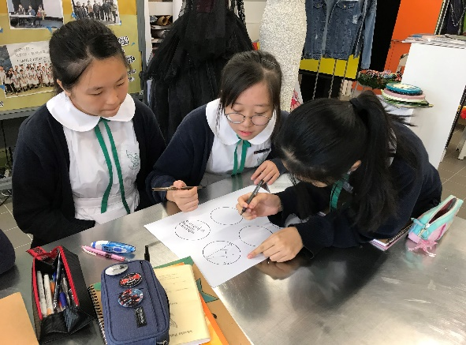  Photo 1. A group of students is working on the 12 Circles Challenge. | Ink pens or markers and A3 papers printed with circles
5 mins | Introduction of the new project  【Creative Ink Painting for the public figures】 | - Show the Contrast between Traditional and Creative Ink Painting on Portraits
10 mins | Appreciation and identification of the artworks | - Appreciation on a local artist: Wilson Shield (石家豪)  Introduce the artist good at Chinese Ink Painting on creating characters in creative ways, applying SCAMPER method:  Examples:  - (Combine)  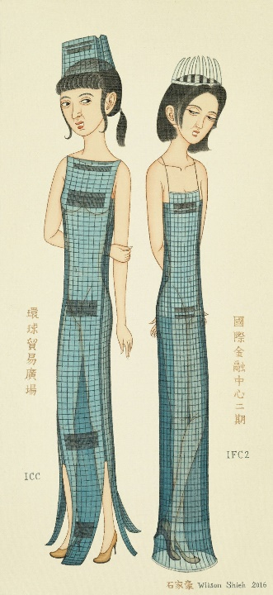 | Teacher’s PPT  Projector  Showing photos of the artist artworks
5 mins | Introduction of the elements in SCAMPER:  - definition  - examples  Understand the possibilities of the technique of SCAMPER | - Motivated warmup activity  Reference photo showing:  - Definition of S.C.A.M.P.E.R.  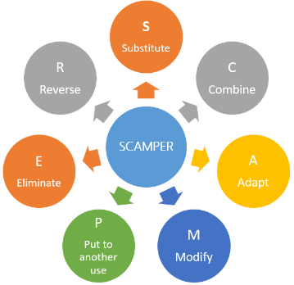  - Example application: “KitKat”  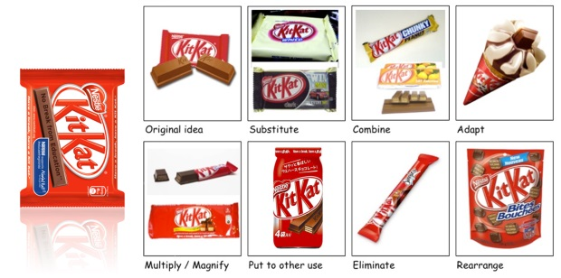 | Showing artworks
10 mins | Experimental practice:  - Students have to choose the pre-set photos of public figures  - Create their own characters for the public figure | - In-class exercise  【Create the character for the public figures】  Students can use markers to apply the SCAMPER method to the chosen pictures  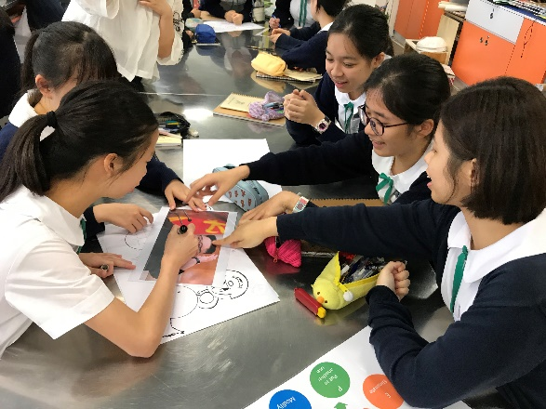  Photo 2a. Students apply the SCAMPER method to the chosen pictures.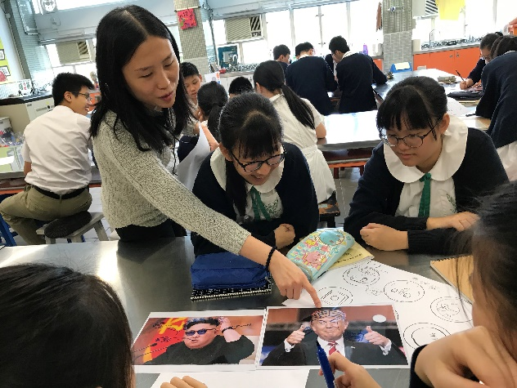  Photo 2b. Students apply the SCAMPER method to the chosen pictures. | Printed A4 size pictures of Trump (President of US) and Kim Jong-un (the Supreme Leader of North Korea)
5 mins | Summarized appreciation | - Summarization appreciation  After groups finished their works on teacher can show the good works  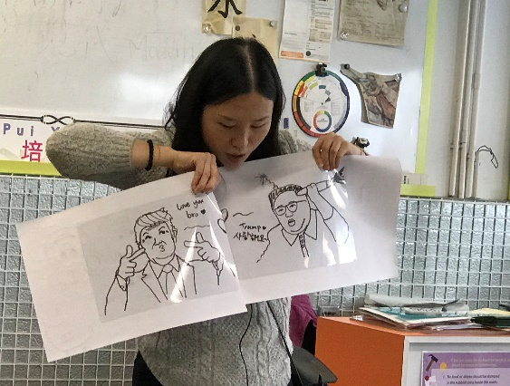  Photo 3. Teacher is sharing one group work with the whole class.  Teacher’s perspective of appreciation:  - Application of SCAMPER  - Use of visual elements  - Measurement of creativity  - Cultural context
 | Conclusion and clean up | - Round up conclusion  Teacher reminds the students again the application of SCAMPER, and encourages them to use this method frequently. | Each students should bring the pictures of their chosen public figures to the next class

教學反思：

雖然創意教學策略需要較長時間才見成效，但在創意教學試教時，學生踴躍參與，氣氛相當好，學生也期待下一課的來臨，可知策略是有正面果效的。
透過課堂上連續的聯想活動，有效刺激學生體驗，尤其改善學生專注力問題。使用創意教具也能時常提醒學生一些創意方法和設計元素。
不過由於課時所限，課堂所相隔時間長，重温內容較為費時。綜觀教研前後，學生最顯著的不同是親自表達期待上課。
參與今年卓師工作室可擴闊同工交流圈。透過卓師工作室的閱讀分享，同工推介有利工作的書本能省時覓得資訊。
未來我會進一步嘗試Scamper , association 及象限分析。

